07-03-2025

Deep learning DOCUMENTATION

# Perceptron

* Algorithm
* Supervised ml
* Mathematical model or function

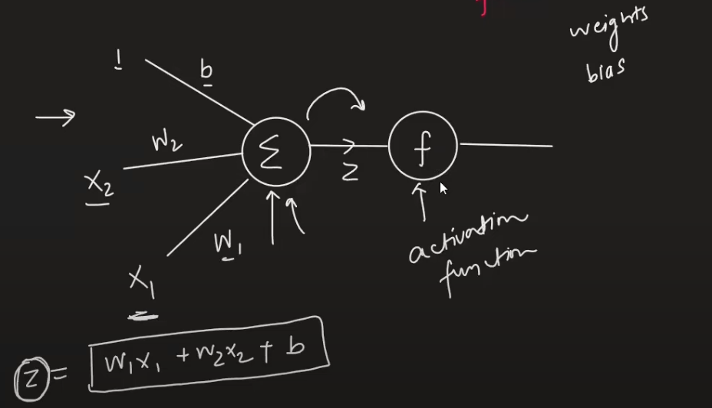

* Activation function is used to bring the value of z in some range like (0,1) or (-1,1)

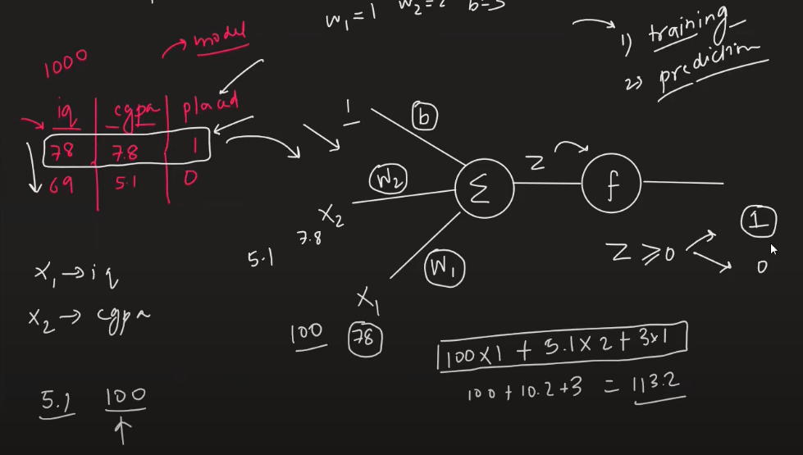

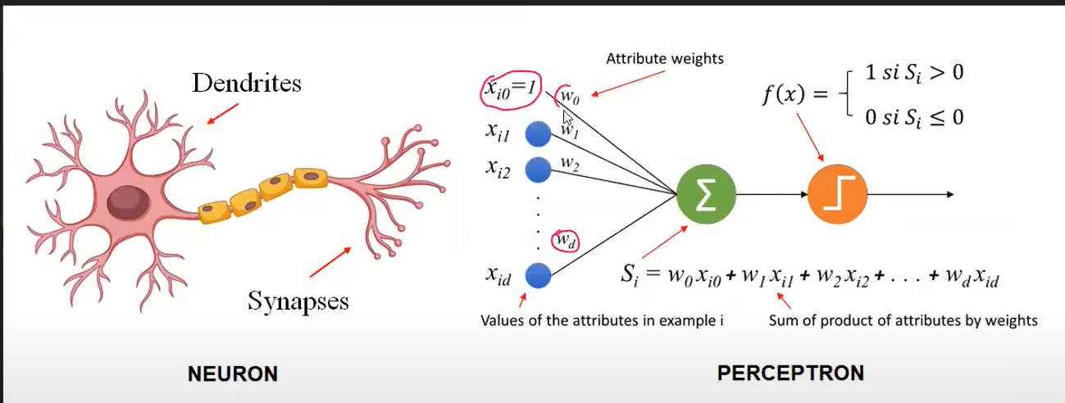

## Interpretation

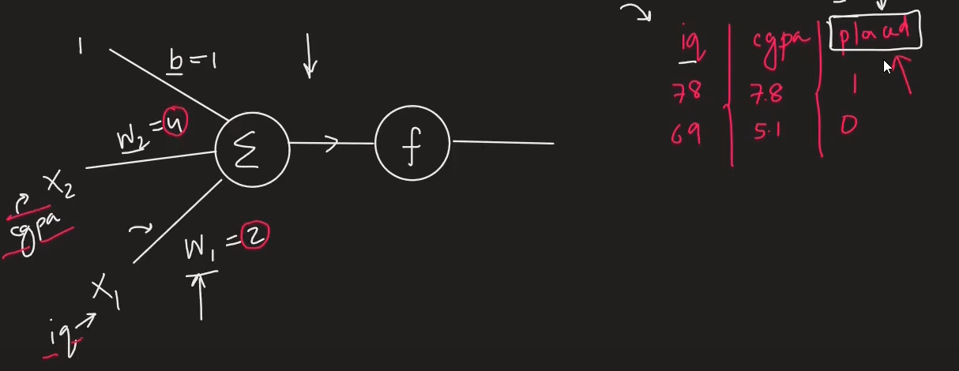

W1 and W2 are weights that explain what is the importance of feature to predict the outcome in our case iq and cgpa. {Feature Importances}

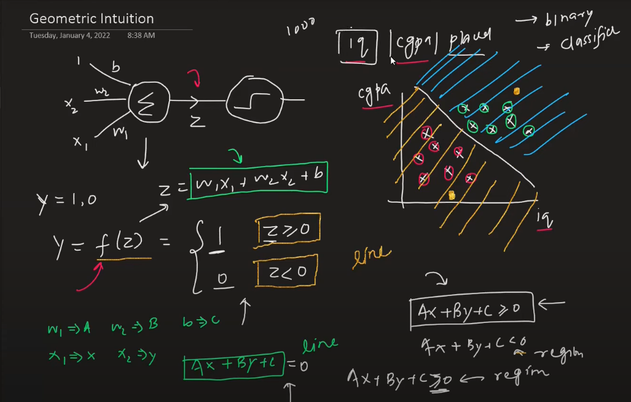

* 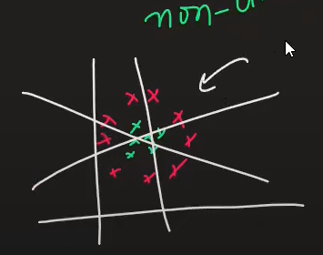Perceptron is like a line for creating a region and dividing the class. {Binary Classifier}
* For 2 d – line
* For 3 d – plane
* For 4 d onwards – hyperplane
* Limitation – works on linear or sort of linear only, perceptron will fail if u have nonlinear data
* E:\DeepLearning\1_Perceptron-Demo.ipynb

Check this file to clearly understand weight and b calculated nothing but m and c in line (y = mx+c)

# How to train a Perceptron

1 Using Perecptron trick

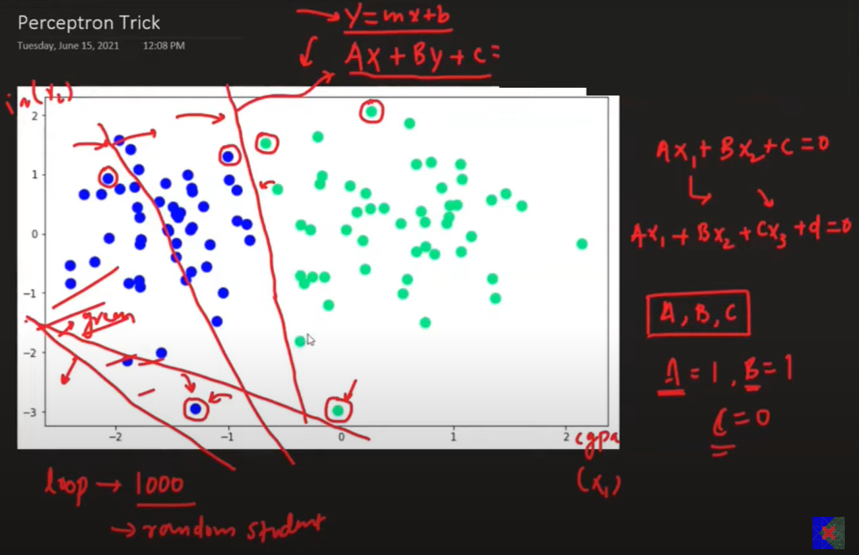 Run a loop for min 1000(epochs) time ask each point classified properly if yes then don’t change the line if no then change it.

Transformation

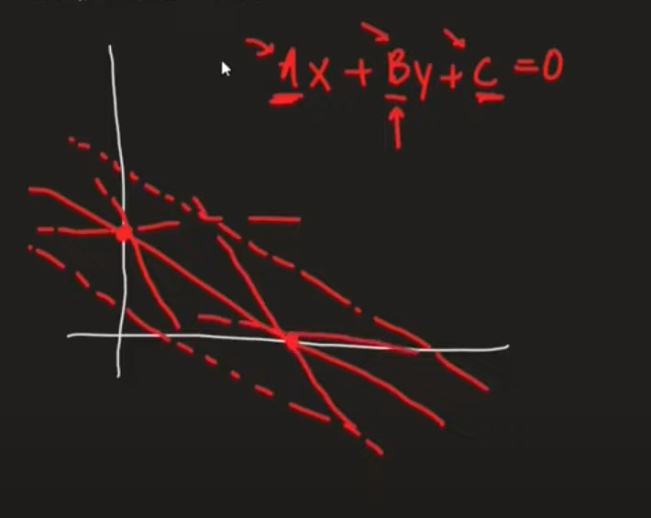If you change the value of c it is like moving upward or downward (c > then down c < up [dotted line])

Llly for a and b check in desmos tool

If a point is not correctly classified , based on the region you will add or subtract such that the line will correctly classify the point

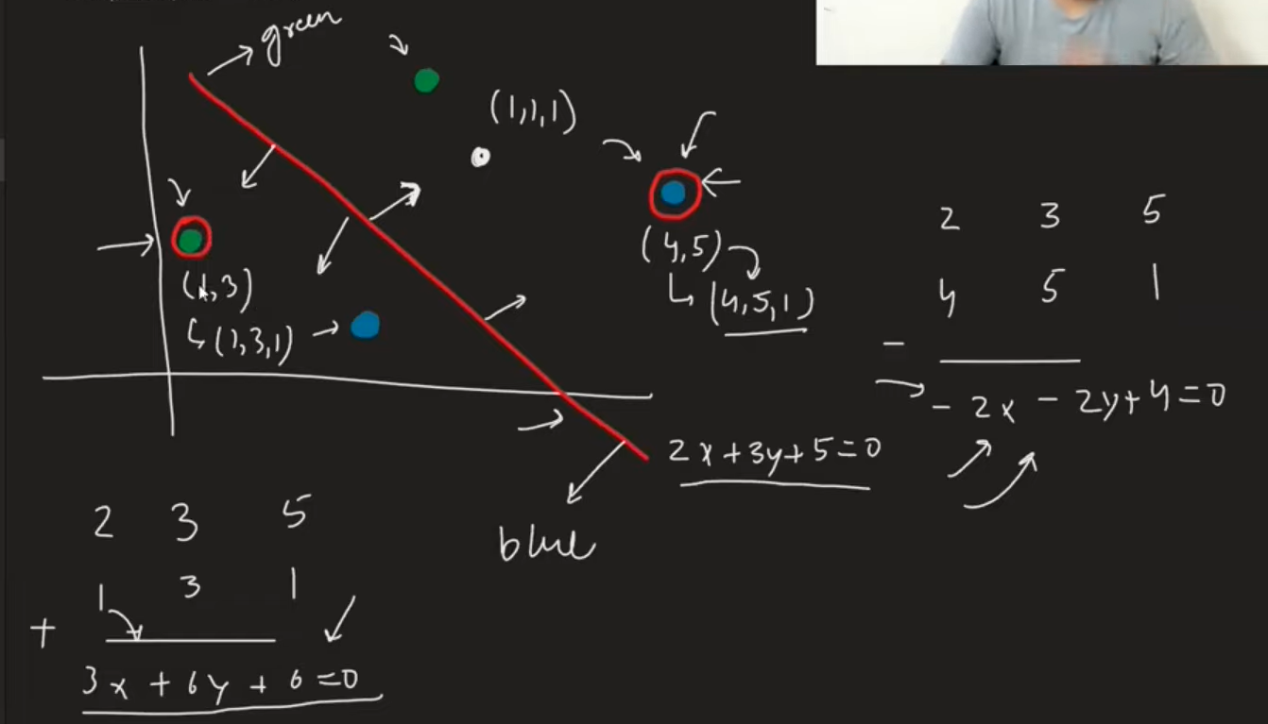

You usually don’t multiply directly the coefficient of line with the point , you multipy the point with learning rate usually 0.01 so that transformation happens in a such a way that points classify correctly.

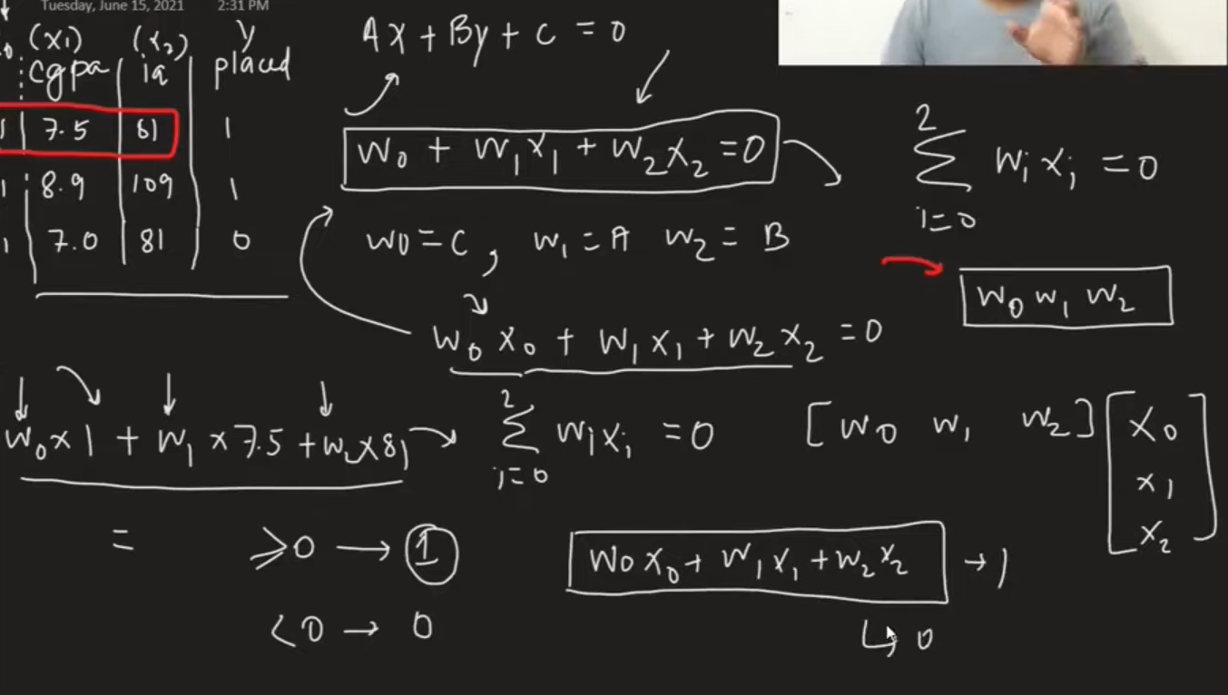

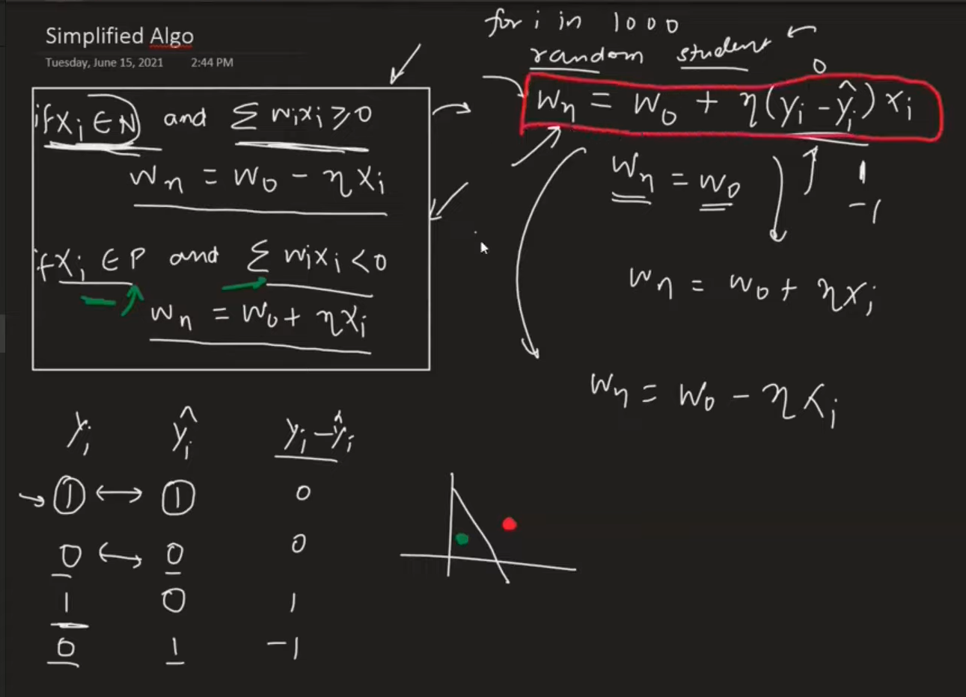

1. Perceptron Loss Function

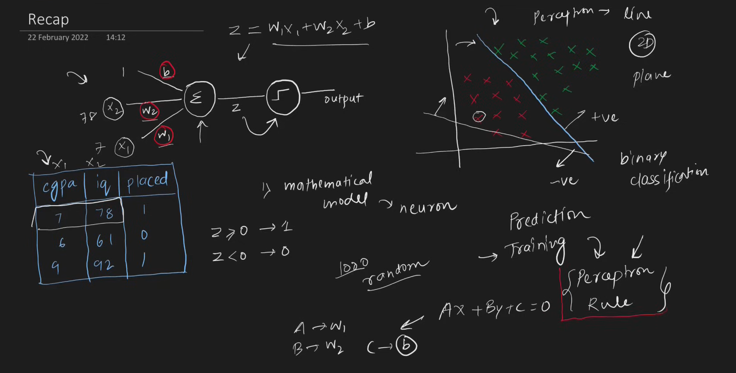

* Problem with perceptron trick
  + - If the value does not change in w1 ,w2 and b2 the line will not move or else the line will move if any changes
    - You can get any line and you cant quantify your result and you cant tell which line is best
    - Convergence problem possibility (like using same value for every epoch , it will not happen but there is a possibility )

Loss Function

* + - Is a way to tell that how the model is performing good or bad
    - It will give u a number that will tell how good is it
    - Simple term , it is a function which gives minimum value

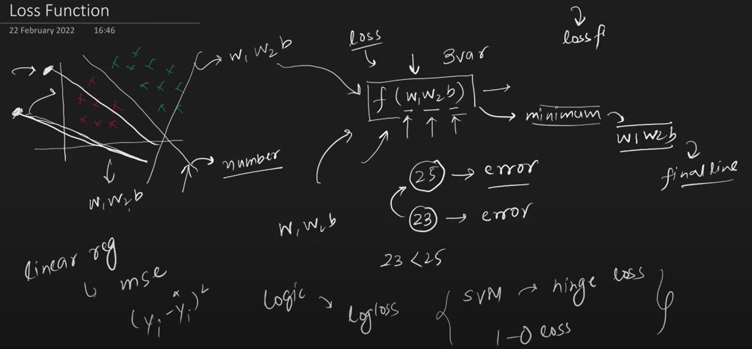

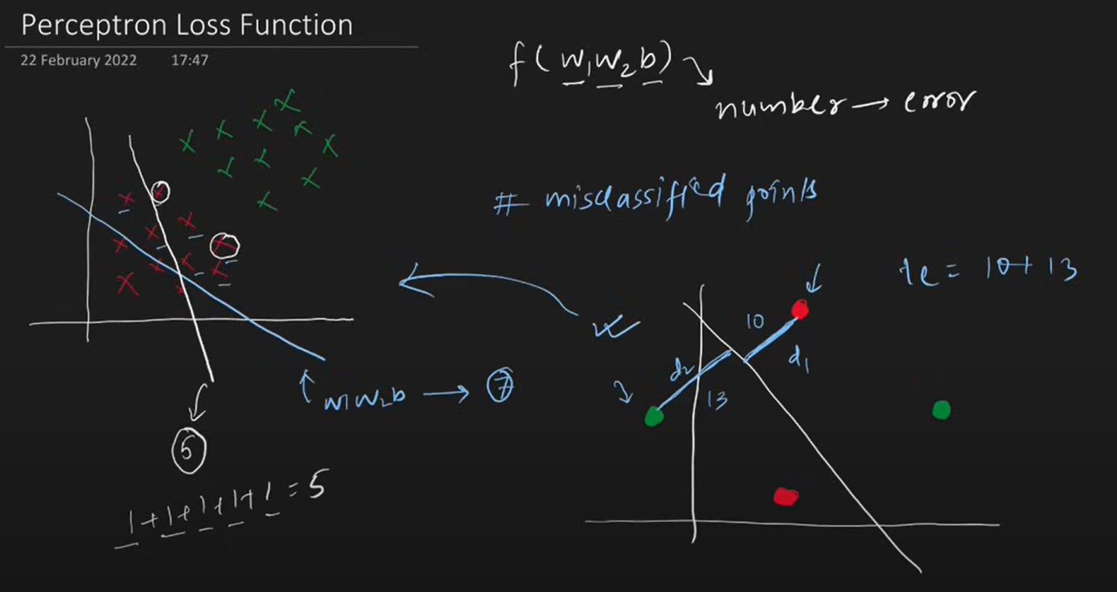

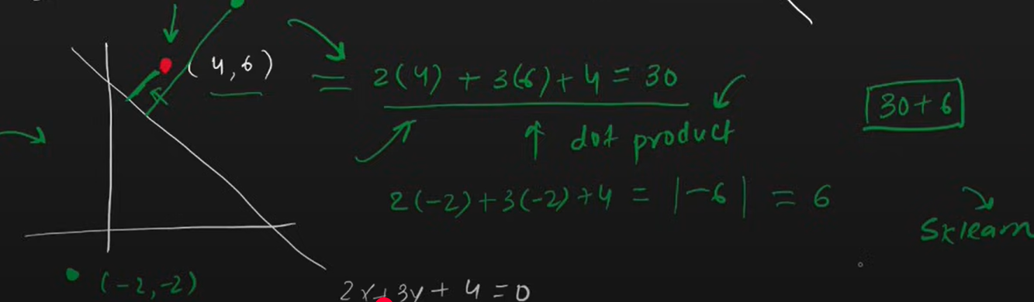

The Loss function implemented in sklearn for perceptron Is

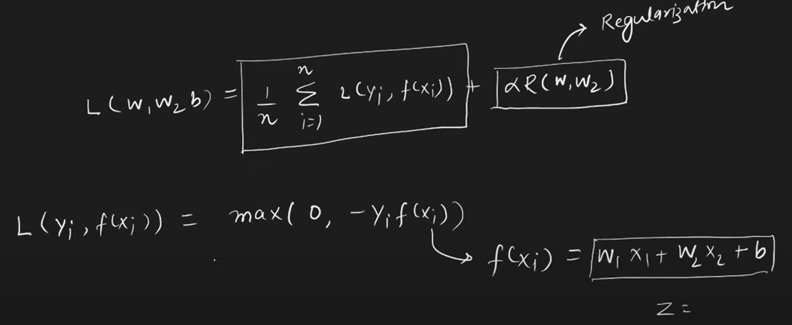

N – number of rows

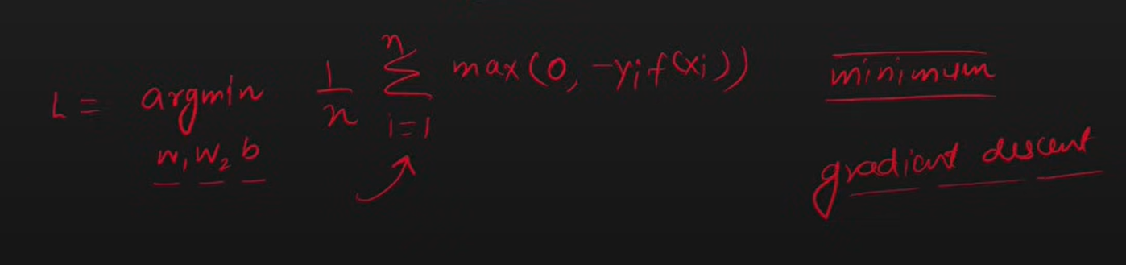

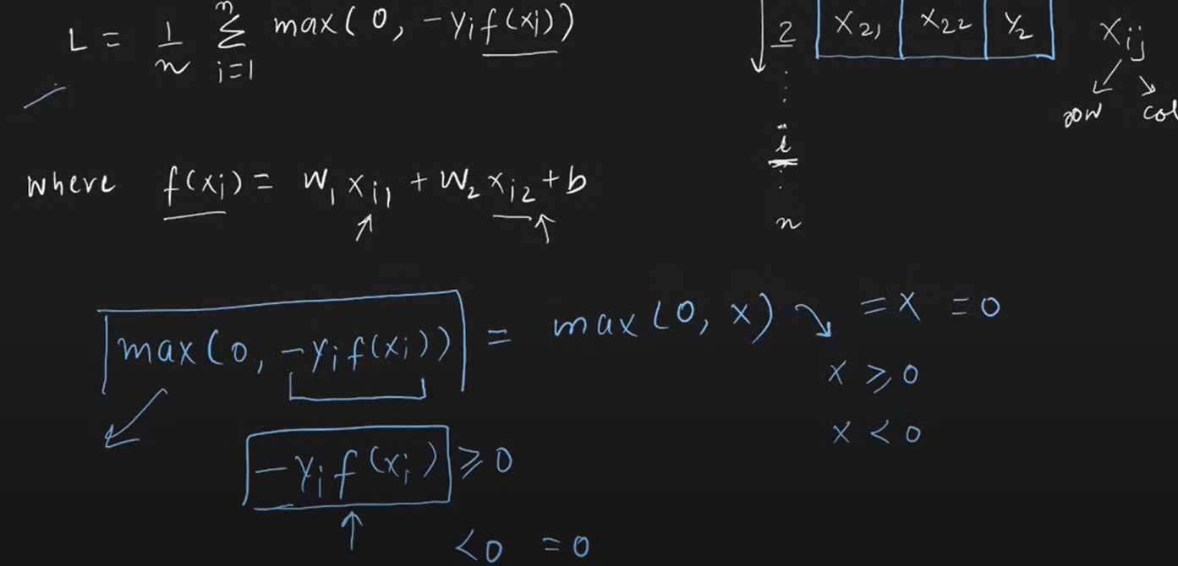

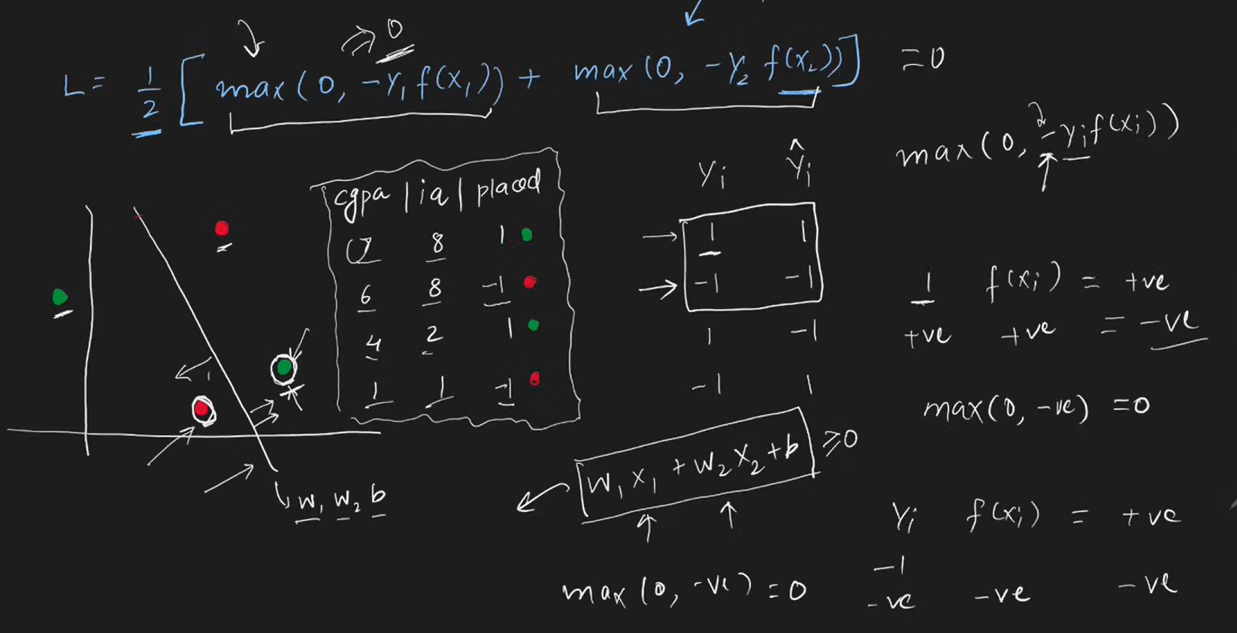

If point is correctly classified then that point does not contribute in the loss function

Gradient Descent Optimization Algorithm

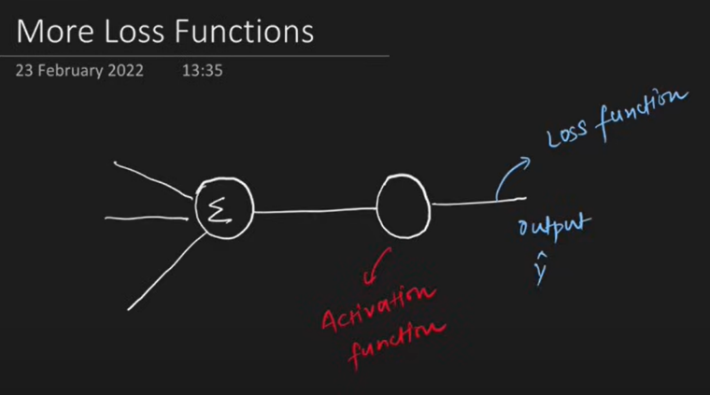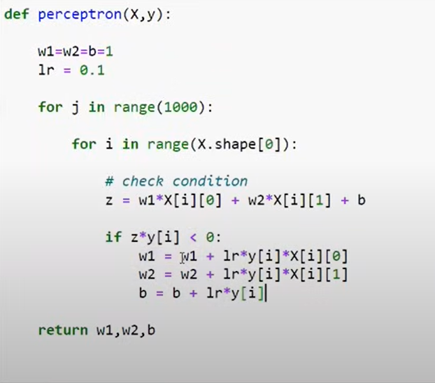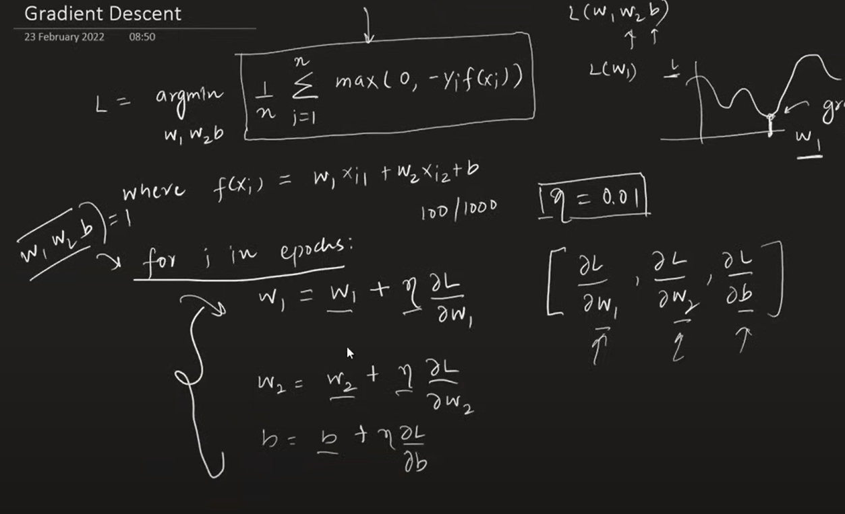

{ MORE FLEXIBLE ,MATHEMATICAL MODEL}

|  |  |  |
| --- | --- | --- |
| Activation Function | Loss Function | OUTPUT |
| STEP | Hinge Loss | 1,-1 (binary classifier) |
| SIGMOID | Binary Cross Entropy /log loss | 0,1 (binary classifier) |
| SOFTMAX | Categorical Cross Entropy | Multiclass prob |
| Linear | MSE | ANY NUMBER |

**NOTE**: PERCEPTRO IS ALSO CALLED AS LOGISITIC REGRESSION WHEN YOUR ACTIVATION FUNCTION IS SIGMOID AND LOSS IS BCE

# Problem with Perceptron

Works only with linear data not on non linear data because essentially perceptron is a linear model.

The problem with Perceptron lies in their limitation to learn complex patterns and functions, especially those that are not linearly separable. A Perceptron is a single-layer neural network with binary outputs, and it can only solve problems where the data points are linearly separable. If the data is not linearly separable, a Perceptron cannot converge and find a solution.

<https://playground.tensorflow.org/>

# MLP Notation

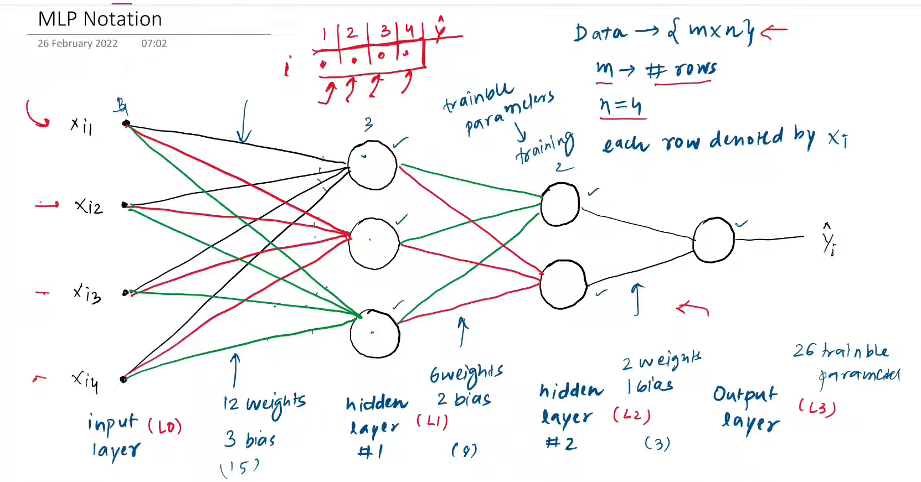

I – layer

j- node

<https://youtu.be/H0_3SJh4Rqs?si=0gm1JLjvhItYEN1g>

# MultiLayer Perceptron | MLP Intuition

A Multi-Layer Perceptron (MLP) is a type of artificial neural network characterized by its multiple layers of nodes (neurons). It consists of an input layer, one or more hidden layers, and an output layer. Each connection between nodes is associated with a weight, and each node applies an activation function to the weighted sum of its inputs. MLPs are trained using algorithms like backpropagation to learn and make predictions.

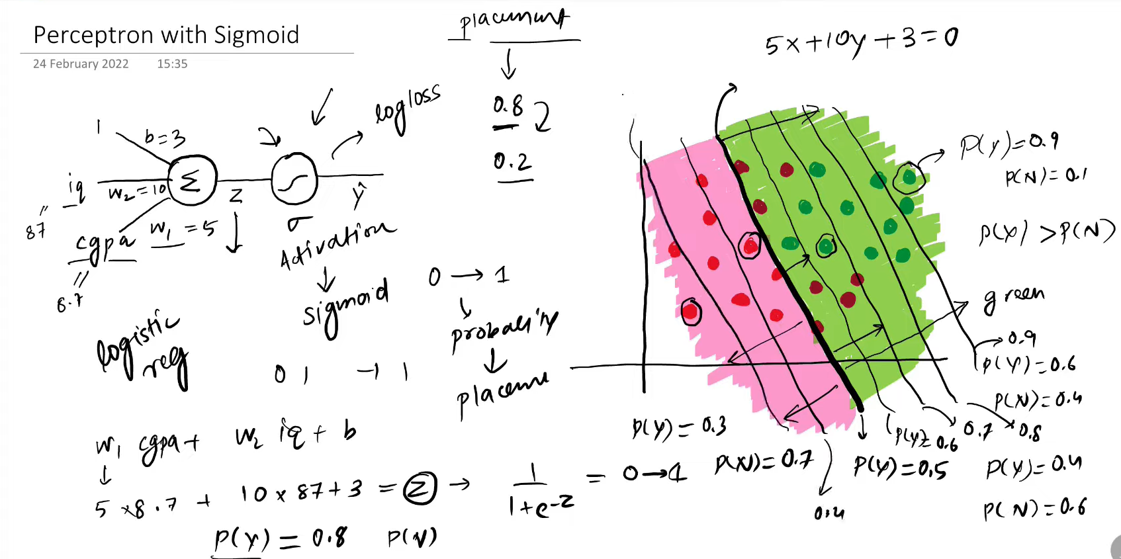

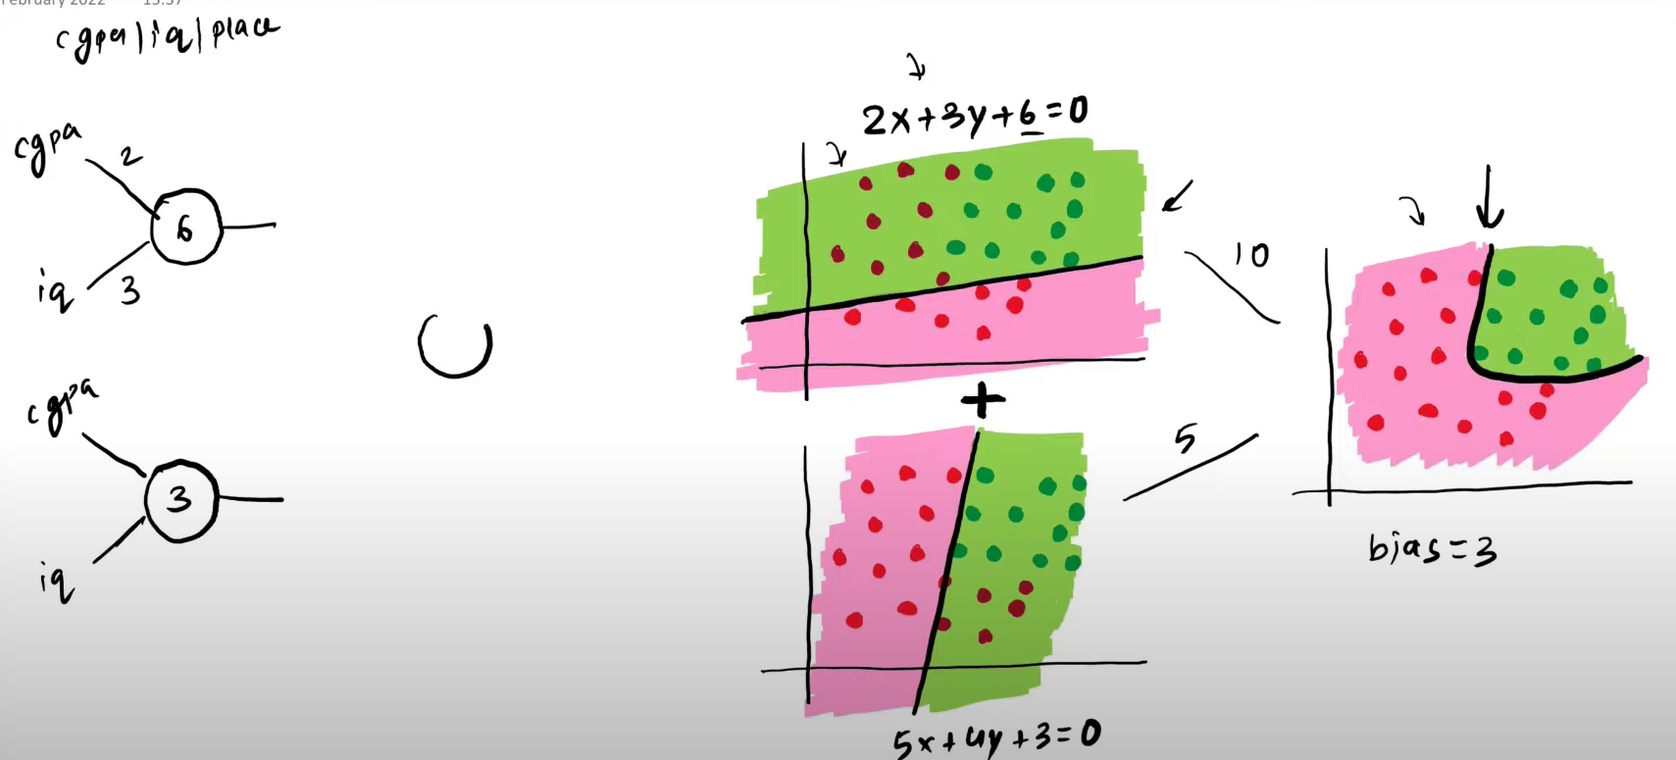

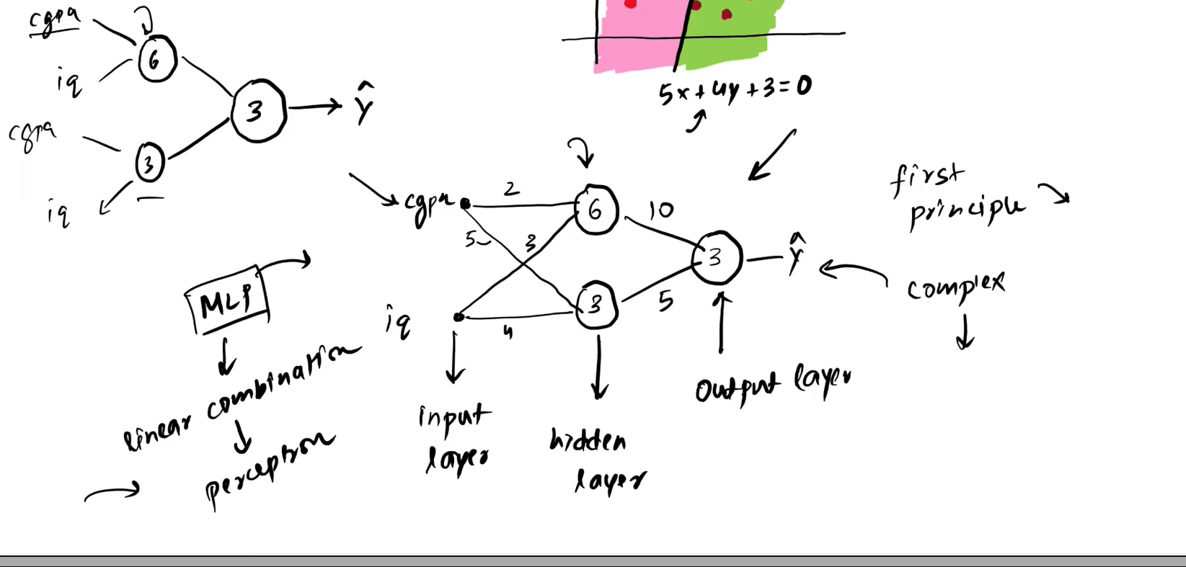

How to get more accurate result | Change Architecture

* Add more node to capture more non linear decision boundary

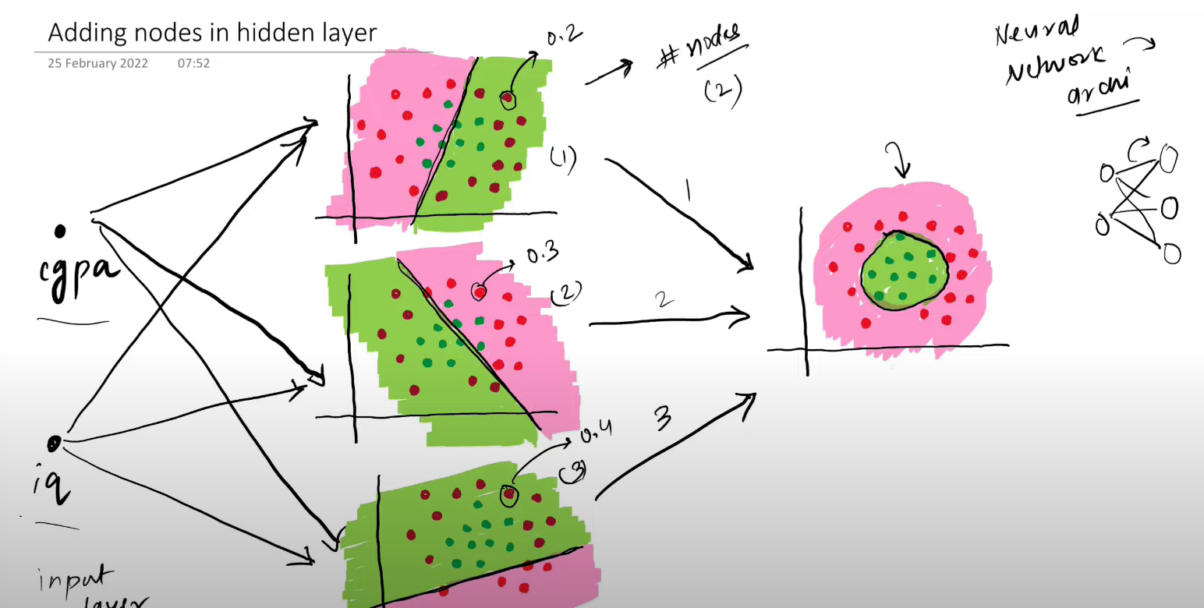

* Add more input column if you have
* Adding nodes in output node (Generally when u work on multi class classification)
* Add more hidden layer to capture more complex relationship

# Forward Propagation | How a neural network predicts output?

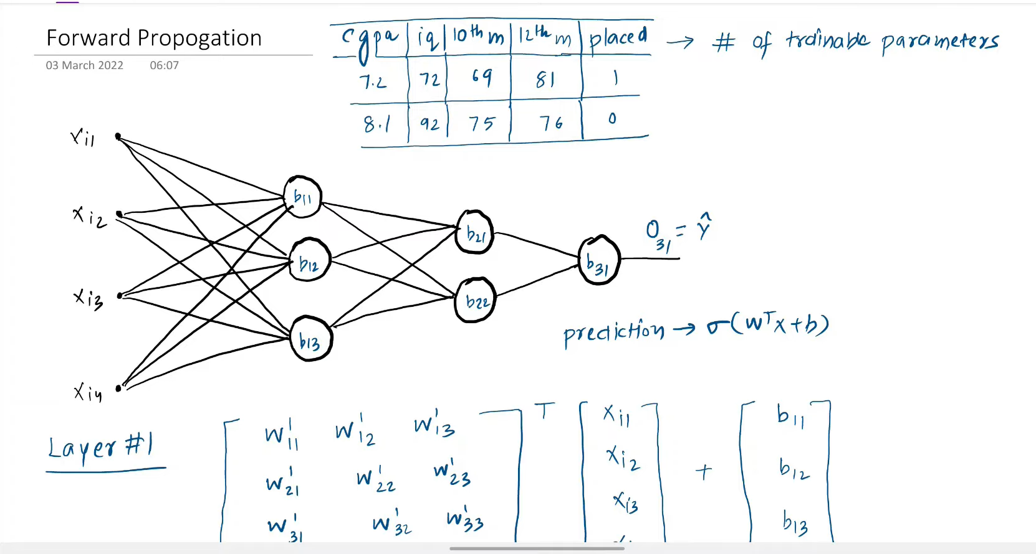

There are 26 Trainable parameter

Input layer to first hidden layer 4 *3 = 12 +3 biase similarly

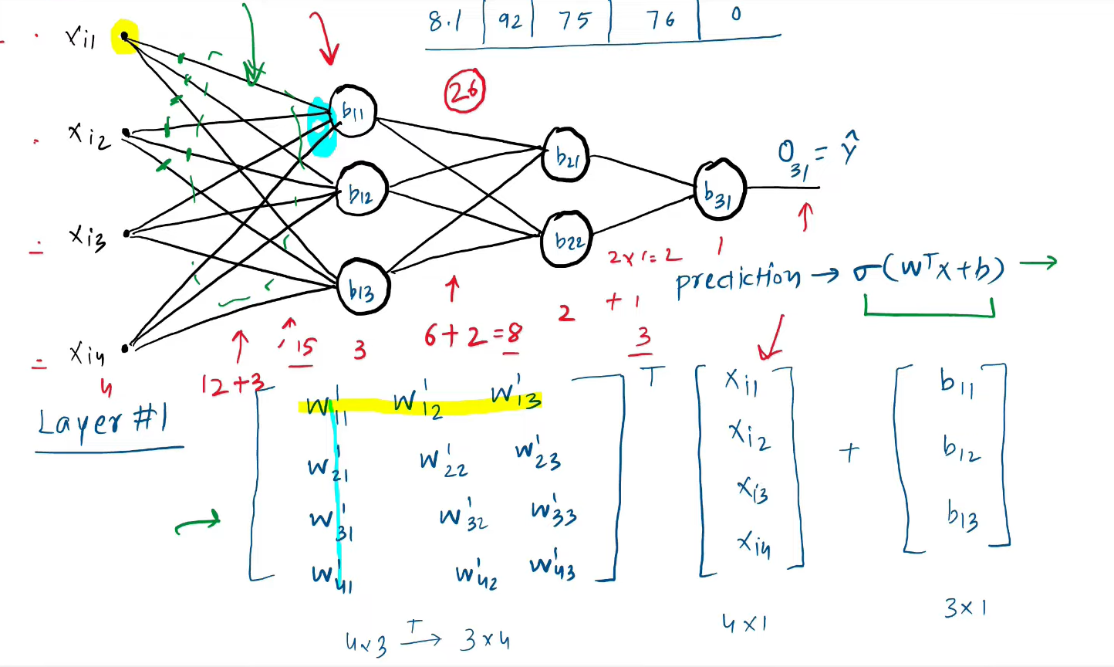

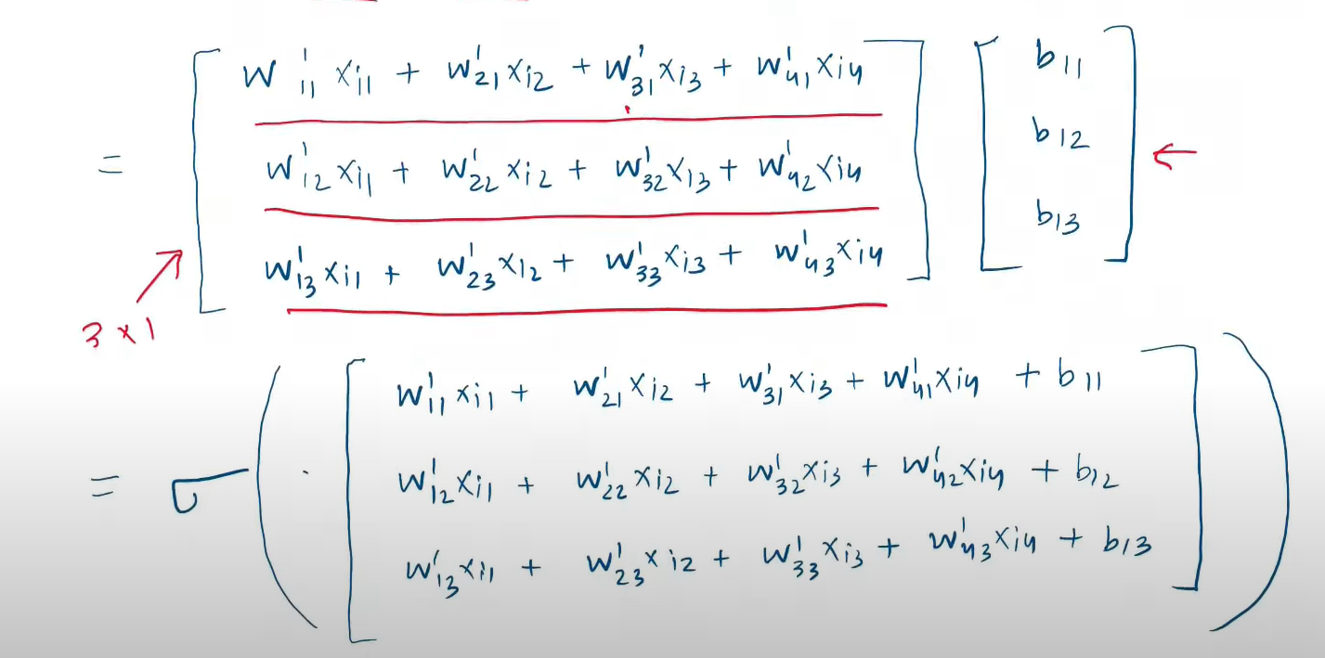

The sigmoid function will give you output as o11 , o12,o13

